Name: Muhammd Sherjeel Akhtar

Roll No: 20P-0101

Home Work No: 1

Subject: COAL LAB

Submitted To Respected Sir:
Khurram Shahzad

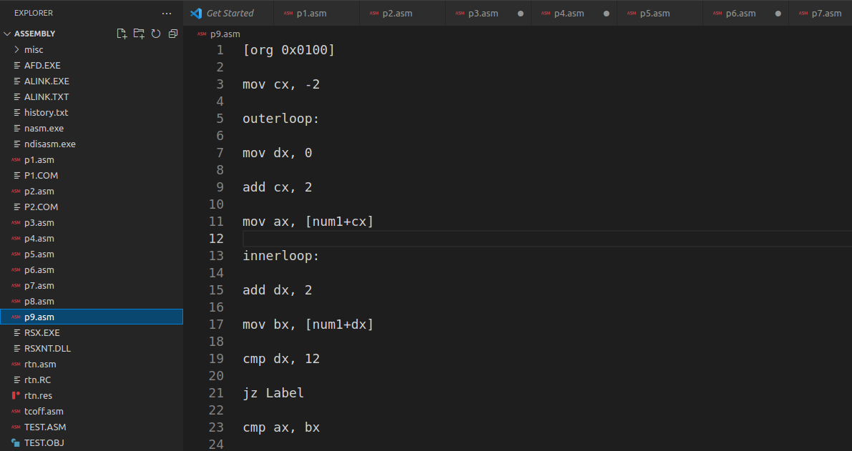
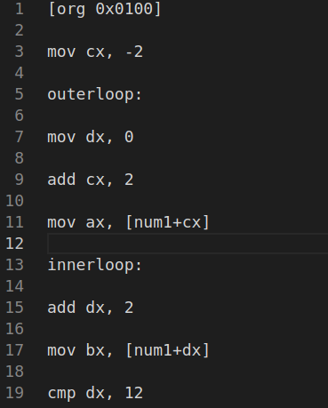

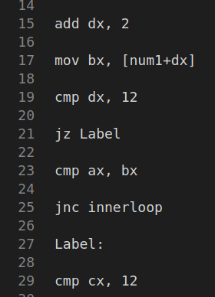

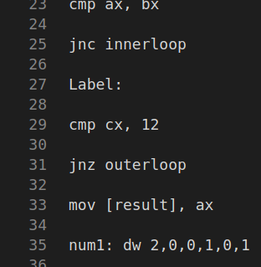
\

Before start of program: 0 is stored in result.

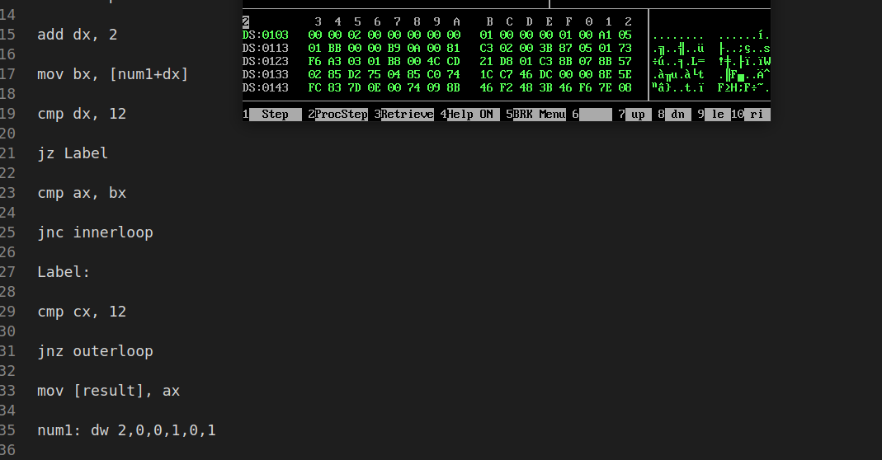

After Storing the highest no: Which is 2 in my roll No: 20P-0101

